I!! Add cover Add comment

**How Traders Make 10% Per Month**

Its having small risk that makes the money

Trade from levels that should see institutional sponsorships, daily weekly monthly levels Pay yourself when its available

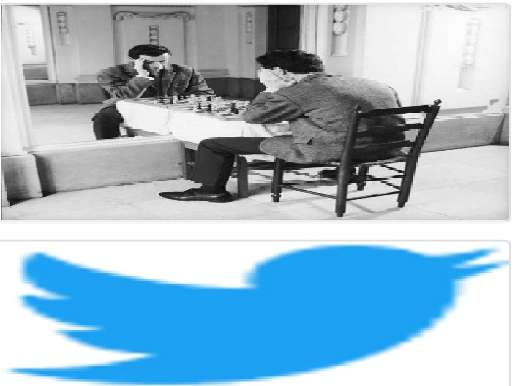Arjo I Twitter, lnstagram I Linktree

Linktree. Make your link do more.

, https://t.co/HhmmTN1fUI

JavaScript is not available.

***'!I*** https://twitter.com/arjoio